**ReactJS – Origami Platform Workshop – Part 2**

## Overview

**First Path**

**Publications view**, which shows all created posts ever.

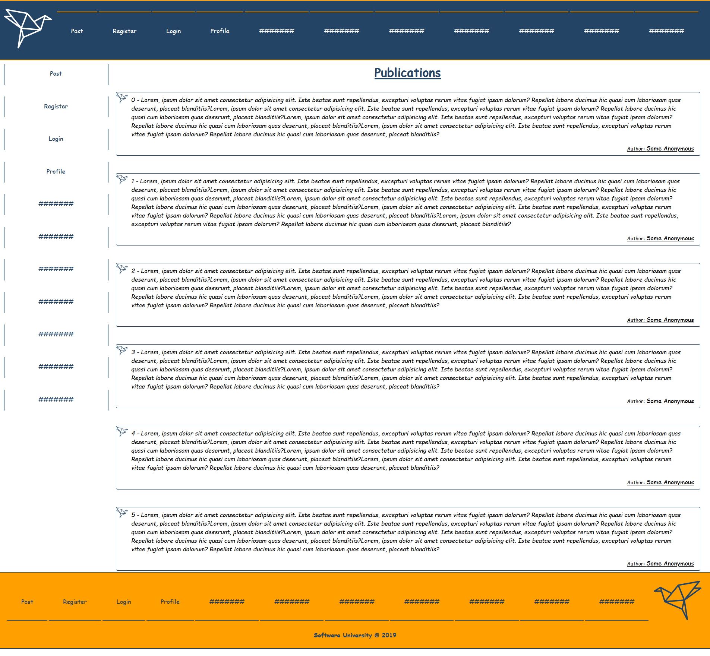

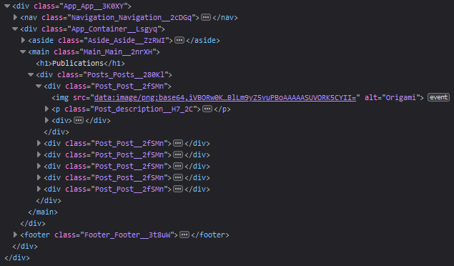

.Main {

    display: inline-block;

    width: 83%;

    height: auto;

    margin-bottom: 5%;

}

h1{

    text-align: center;

    color: #234465;

    text-decoration: underline;

    margin-bottom: 2%;

}

**Second Path**

**Share your thoughts view,** where the user can see the textarea where the post will be created and the last 3 posts ever.

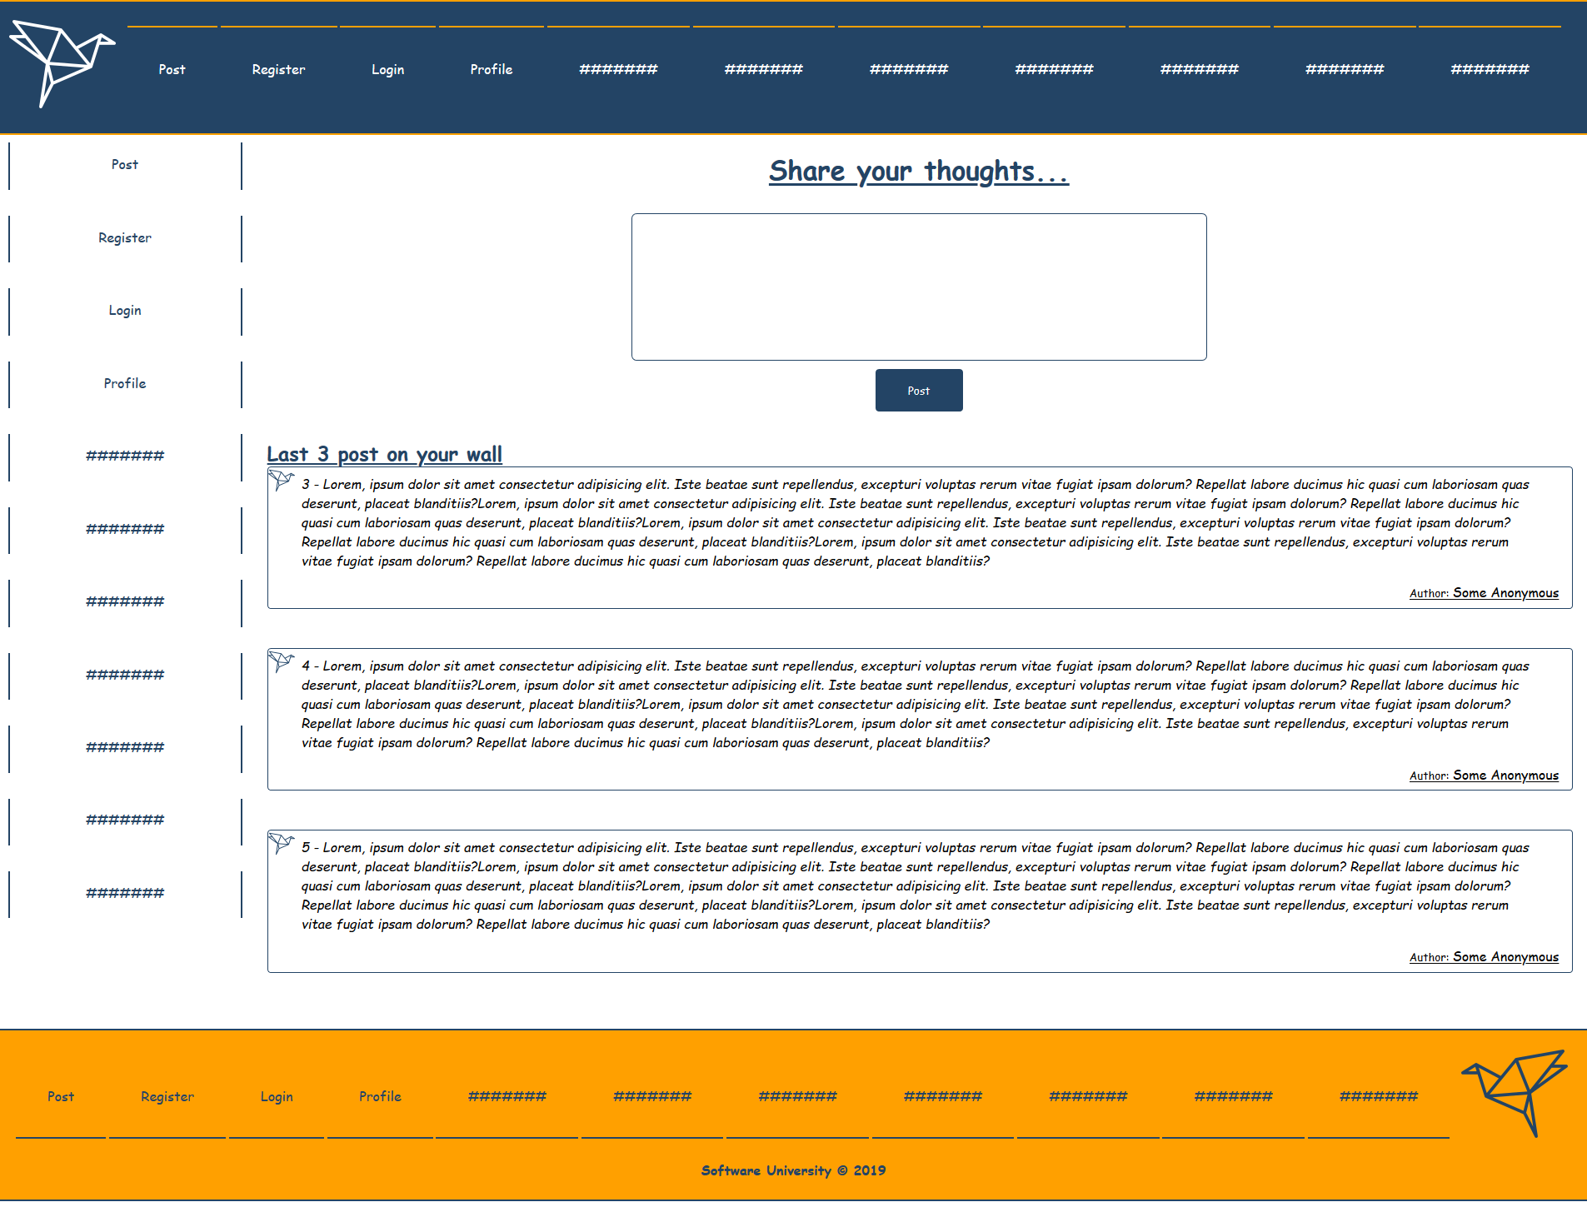

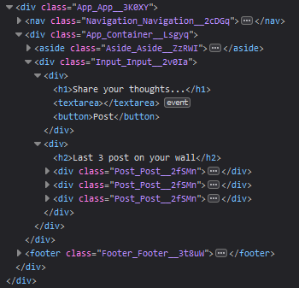

.Input {

    display: inline-block;

    padding: 0.5%;

    width: 83%;

}

textarea {

    width: 40%;

    display: block;

    margin: 0 auto;

    resize: none;

    padding: 2%;

    height: 10vh;

    font-style: italic;

    border-radius: 6px;

    border:1px solid #234465;

    color: #234465;

}

button{

    background-color: #234465;

    color: white;

    padding: 1%;

    width: 7%;

    border-radius: 6px;

    display: block;

    margin: 0 auto;

    border:none;

    margin-top: 0.5%;

    border: 2px solid white;

    margin-bottom: 2%;

}

button:hover{

    background-color: white;

    border: 2px solid #234465;

    color: #234465;

    font-style: italic;

}

.Input h2{

    color: #234465;

    text-decoration: underline;

}

**Third Path**

**Register** **view**, where the users will be registered.

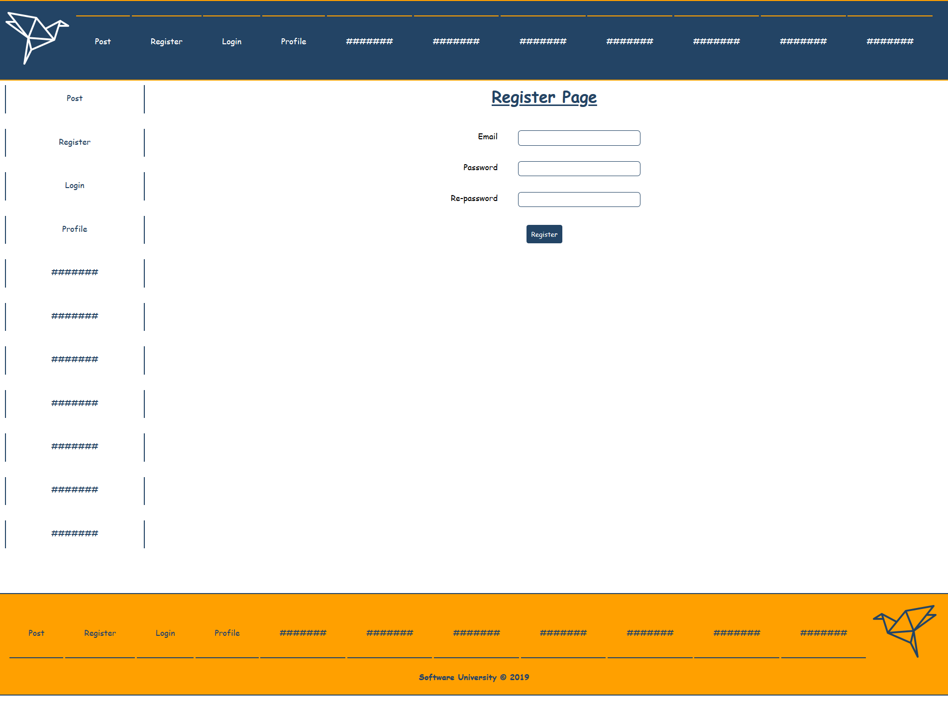

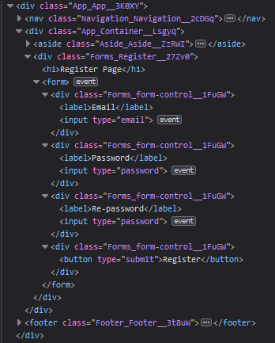

**Fourth Path**

**Login** **view**, where the users will be logged.

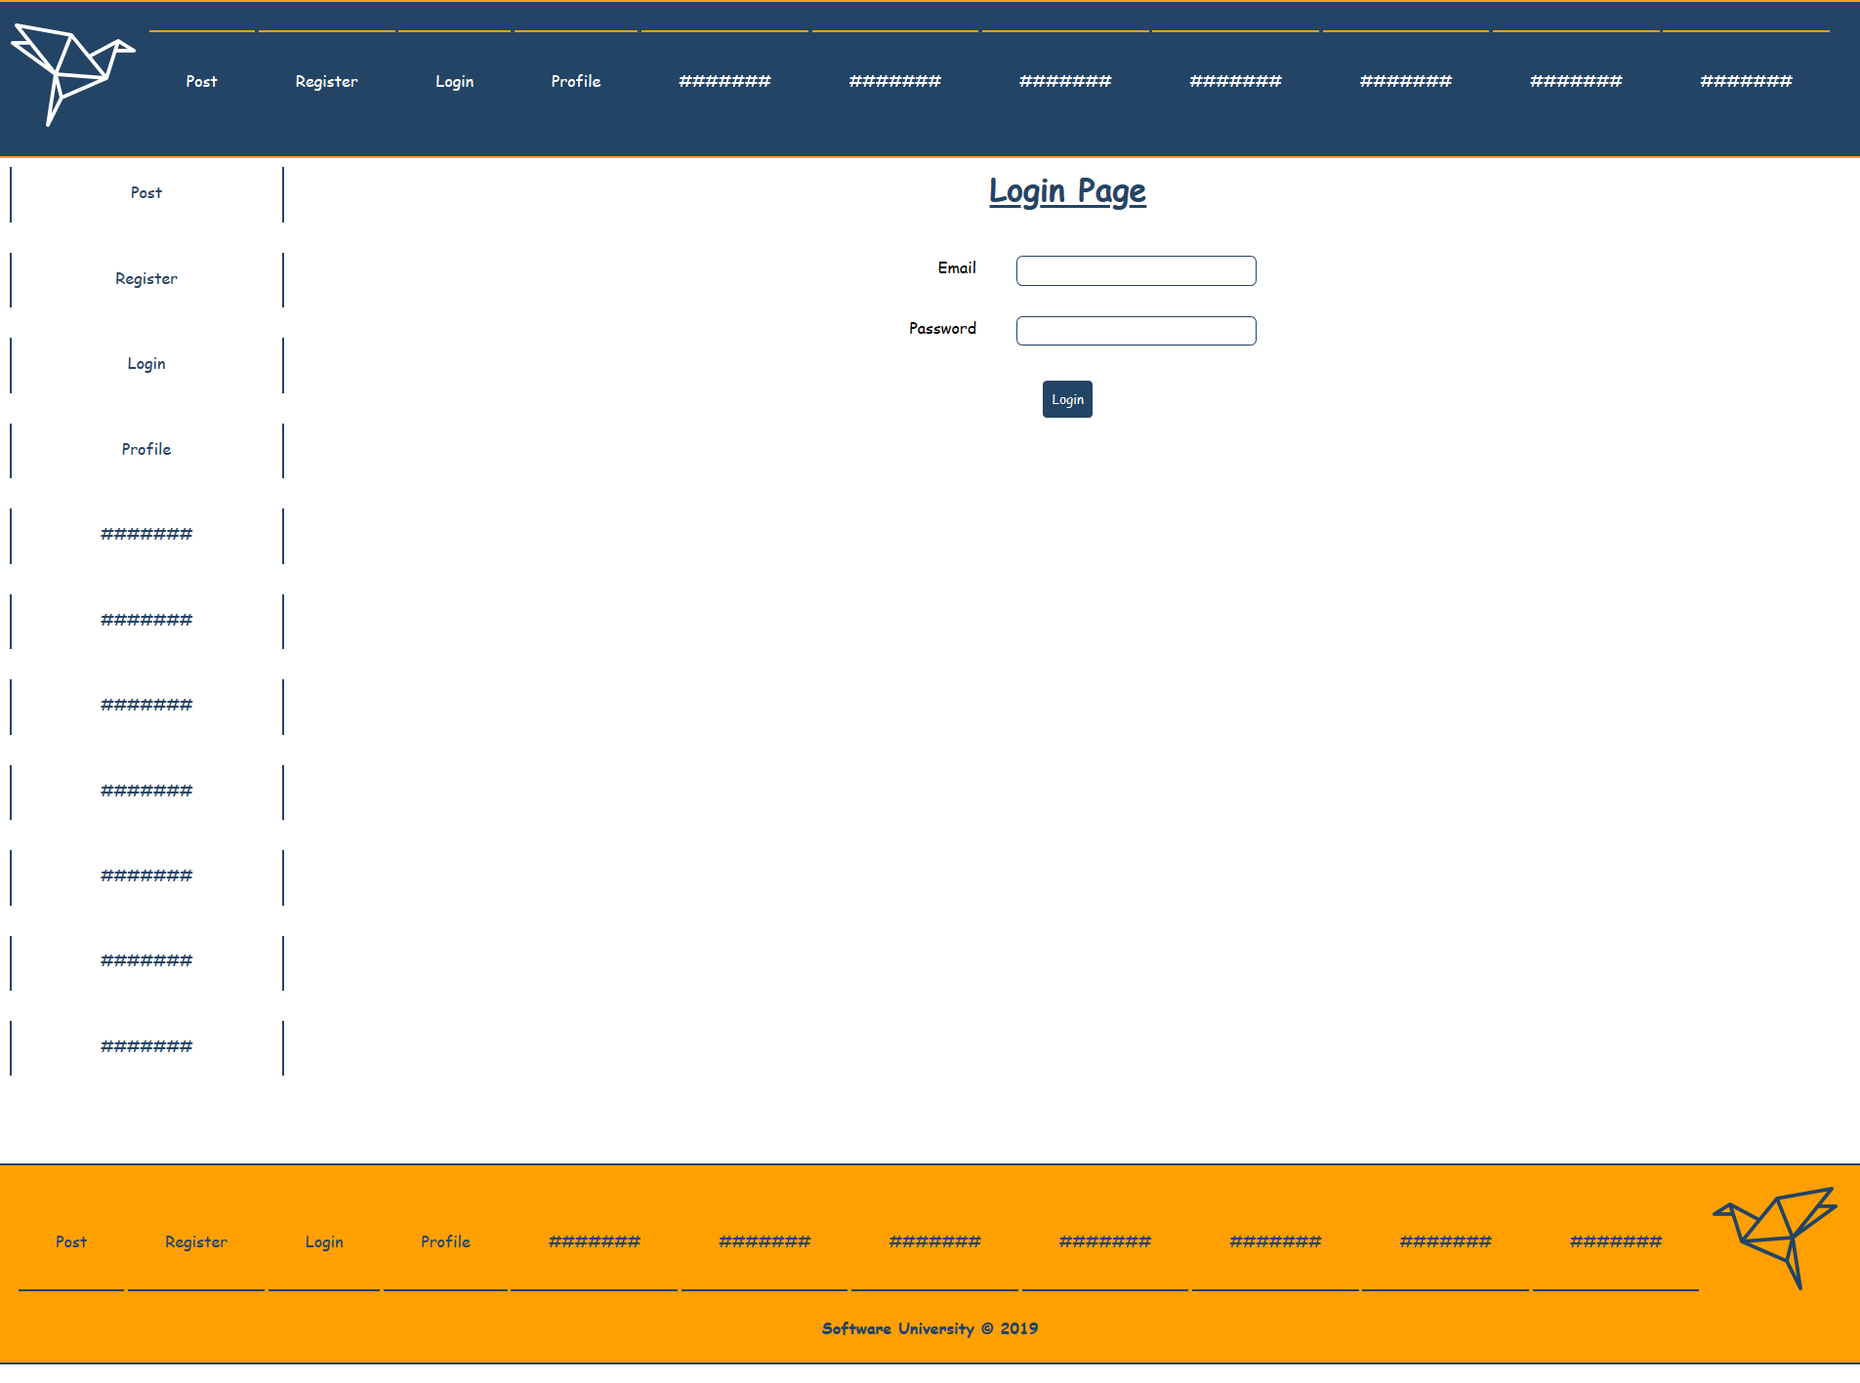

Use these **styles** for **Login** and **Register** **views**

.Login, .Register {

    width: 83%;

    display: inline-block;

    vertical-align: top;

}

.form-control {

    width: 30%;

    margin: 0 auto;

    padding: 1%;

    text-align: center;

}

label {

    float: left;

    width: 30%;

    text-align: right;

}

input {

    text-align: center;

    border:1px solid #234465;

    padding: 1%;

    width: 50%;

    border-radius: 6px;

    color: #234465;

}

form button {

    width: auto;

    padding: 2%;

}

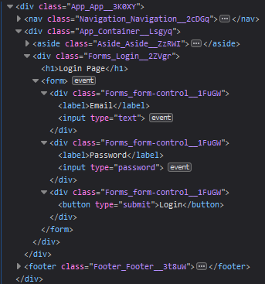

**Fifth Path**

**Profile** **view**, where the user can see his own account information and his top 3 recent posts.

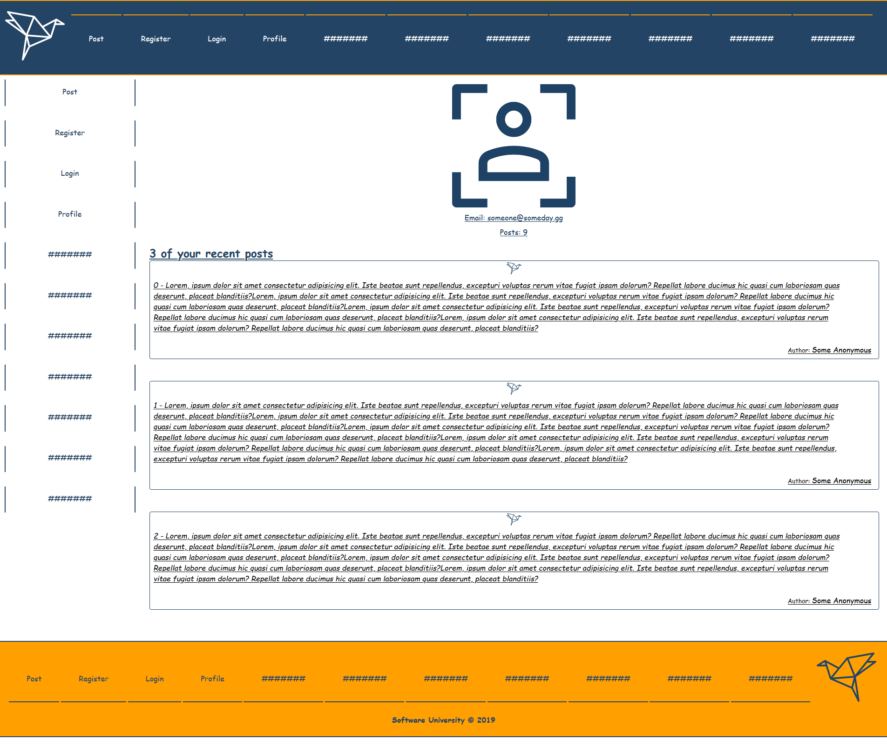

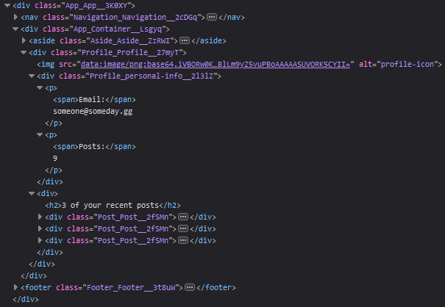

.Profile {

    width: 83%;

    display: inline-block;

    vertical-align: top;

    padding: 0.5%;

}

.Profile img {

    max-width: 265px;

    margin: 0 auto;

    display: block;

}

.Profile .personal-info{

    vertical-align: top;

    padding: 10px;

    margin: 0 auto;

    color: #234465;

    width: 50%;

    text-align: center;

}

.Profile p{

    text-decoration: underline;

    margin-bottom: 1%;

}

.Profile h2{

    color: #234465;

    text-decoration: underline;

}

**Sixth Path**

**404 view for any invalid path.**

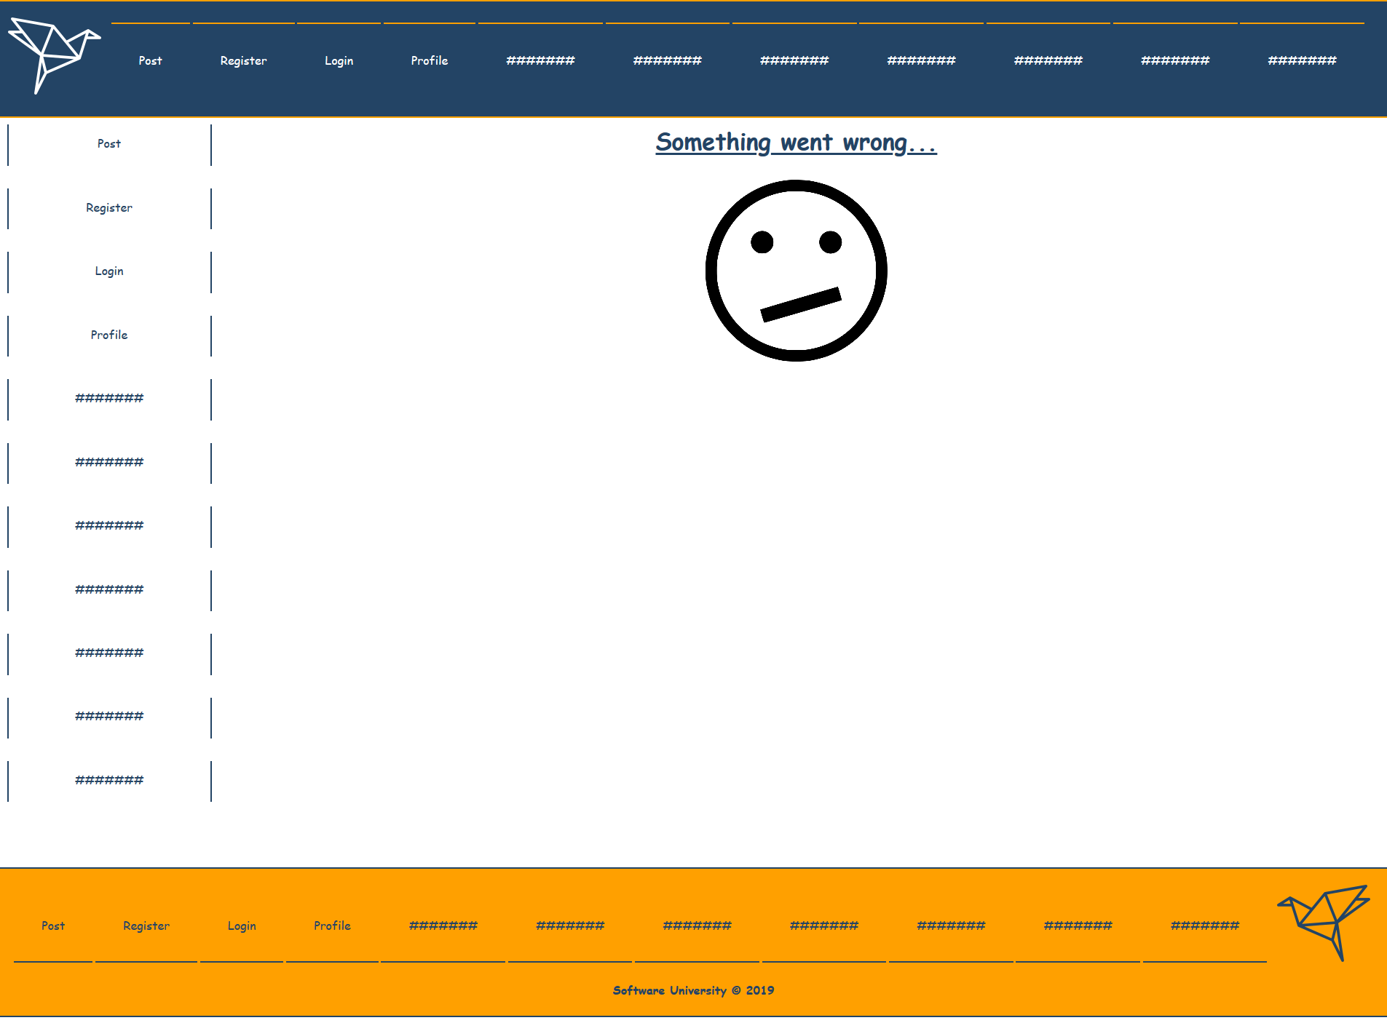

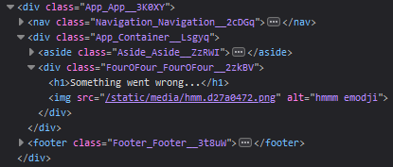

.FourOFour{

    width: 83%;

    display: inline-block;

    vertical-align: top;

}

.FourOFour img{

    width: 250px;

    margin: 0 auto;

    display: block;

}

## Database

Use the provided **REST API** build with **Express.js** and **MongoDB**

You can download **MongoDB** from [here](https://www.mongodb.com/download-center/community) and use a GUI with it like [Robo3T](https://robomongo.org/)

Each **Post** should have a **post description (string)** and a **post author (objectId)**.

Use **Postman** to create some entities or use **"mongoimport"** to [import the data](https://stackoverflow.com/questions/15171622/mongoimport-of-json-file) that is provided to you.

### Server

Use the provided server to fetch all posts and list them into the front-end. The server will listen on port **9999** by default. In order to fetch the data that you fed in the database you will have to make a **get request** on **'localhost:9999/api/origami/'**

## Implementation

Make sure you assign every **required** **attribute** to each Component, so the result is the same as the example above. If at some point something is not right, be free to check the structure picture for each element or directly to the provided CSS. **Also be free to extends the workshop as much as you want!**

***Good Luck 😊***